**CSCI 574 Hw#2 : Mean Shift Segmentation and Watershed Segmentation**

**Name: Manan Vyas  
USCID : 7483-8632-00  
Email:** [**mvyas@usc.edu**](mailto:mvyas@usc.edu)

***1. Mean Shift Segmentation***

**Task**: To segment the given images using Mean Shift[1] segmentation

**Code implemented in: C++, OpenCV**

**Approach and Implementation:** The mean shift filter uses a density gradient to characterize the distribution of pixels in the image. The algorithm searches along the intensity gradients within the image to search for local maxima and find these local maxima points in the colour space of the image.

**Results and Discussion:**

**Image 1 : Spatial Radius = 25 ; Intensity Radius = 18**

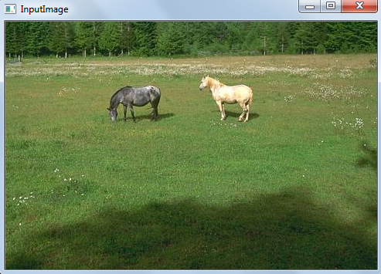

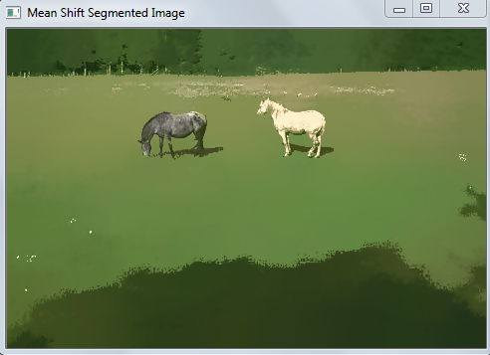

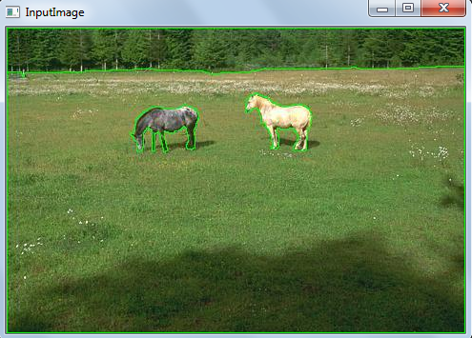

**Image 2 : Spatial Radius = 5 ; Intensity Radius = 10**

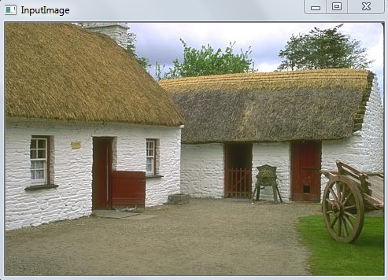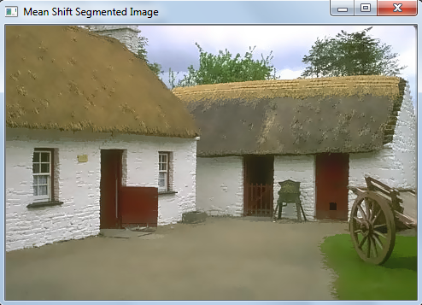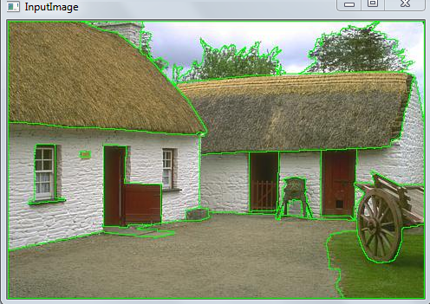

**Image 3 : Spatial Radius = 30; Intensity Radius = 30**

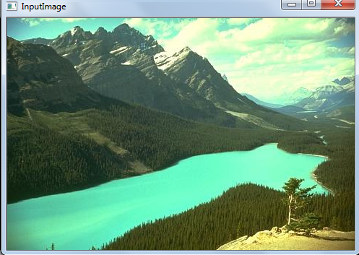

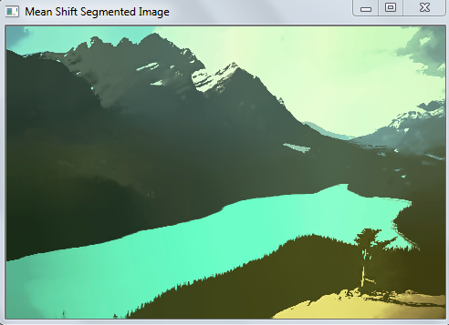 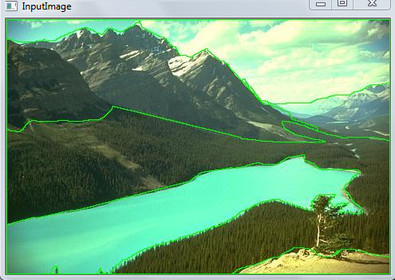

* If we compare the segmented image with the ground truth boundaries, we conclude that mean shift segmentation work very well qualitatively within reasonable amount of variation in the SpatialRadius and IntensityRadius.
* It is thus observed that larger the size of the window, which depends upon the value of SpatialRadius Kernel , more the size window produces more ‘colour blending’ within the different parts of the image. There are less precisely defined edges or boundaries between different parts if objects within an image.
* Too big a spatial radius also distorts the segment boundaries
* More the number of iterations of convergence, more amounts of pixels in window are replaced by the centre of the weights (also called the local

maxima value) and better the image segmentation. However, time complexity of the program increases substantially.

* Just by adjusting the kernel parameters, the SpatialRadius Kernel and the intensity radius kernel we can set the window size and the threshold for segmentation.
* Increasing color radius also helps remove the white speckles, without introducing the edge strips, at the expense of the boundaries between segments.
* Optimum window size for the steepest ascend calculation around the pixel of interest is when the window size = 6* SpatialRadius +1.
* As stated in the homework, CIELAB color space is designed to be approximate to human vision and perceptually uniform. And better segmentation results are obtained when mean shift segmentation is performed after converting the image into L*a*b colour space.
* It is thus concluded, that mean shift filtering does a better job of image segmentation than other techniques like bilateral filtering, Kmeans etc, because the job of handling the clusters is automated in this particular case and it is handled by the window size for mean shifted local maxima calculation.

***2. Watershed Segmentation***

**Task**: To segment the given images using Watershed segmentation

**Code implemented in: C++, OpenCV**

**Approach and Implementation:** Watershed transform is a marker based and a region based segmentation technique. Here we try to create regions of local minima within the image by marking out several areas (called markers) either manually or by some morphological operation on the image. As a result, the image is divided into regions called watersheds[2] .We then try to fill those watersheds of local minimas using a suitable technique like the flood fill.

In the homework, it was given that we could manually select those markers. Hence I used the following approach to generate the markers.

I assume that for any given image, the local minimas will be spread throughout the image uniformly. Hence,I defined seeds to be circular regions uniformly separated by a distance ‘seed_size’ (look in code) along the width and the height to the image. This seed_size can be varied according to the user choice.Once we have the seeds, the OpenCV built in for watershed was used and then as a post processing technique, I ‘flood-fill’ areas adjacent to the seed pixels by the normalized intensities of color.

**Results and Discussion:**

**Image 1: Seed Size = 10 ; Seed Radius = 5**

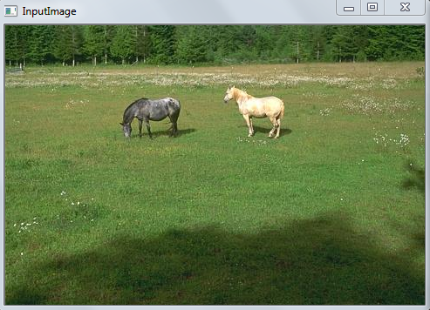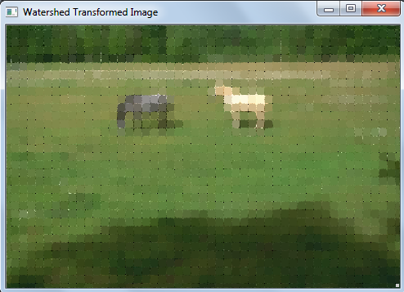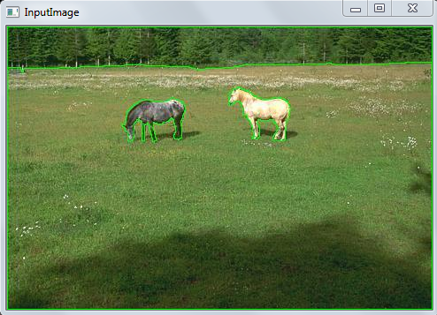

**Image 2: Seed Size = 10 ; Seed Radius = 1**

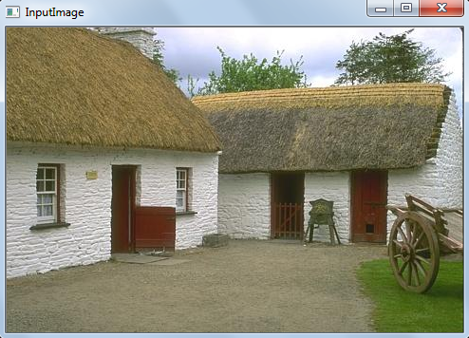 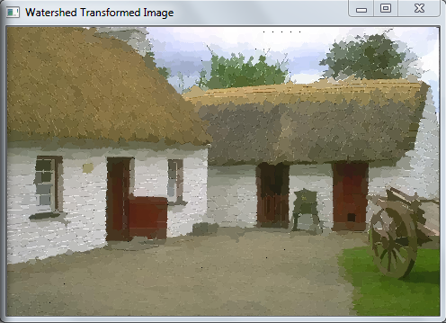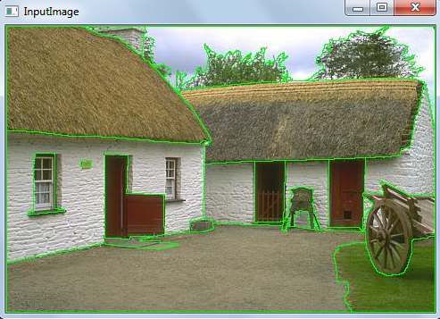

**Image 3: Seed Size = 20 ; Seed Radius = 1**

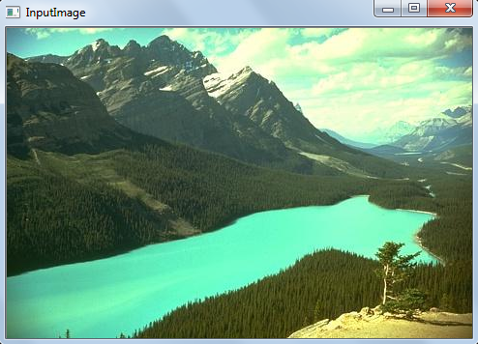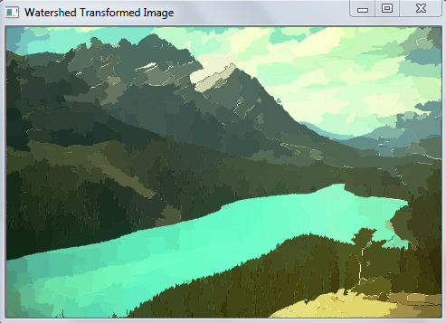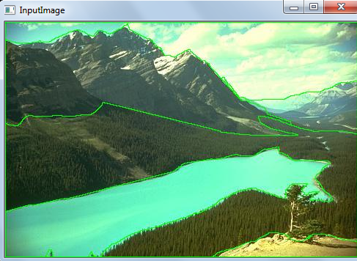

* The size of the region defined to be watershed depends upon the closeness of the seed pixels that are defined.
* Too big a distance between seed pixels the more intensities to be normalized and hence the regions will look blurred espacially around the edges.
* Thus we must be careful while selecting the seeds as the final output and adherence to ground truth boundaries highly depends upon the spacing between the circular regions of the seeds and also on the size of the circular regions of the seed pixel in the proposed implementation.
* Too large spacing between adjacent seeds and too big the radii of the circular region and we lose the qualitatively of segmentation and also lose the adherence to ground truth boundaries.
* Too small spacing between adjacent seeds and too small the radii of the circular seed regions and we get ‘over-segmented’ output image.

**Comparision between Mean Shift and Watershed:**

* The watershed technique highly depends upon the choice of markers. Bad choice result in over segmentation. Good markers produces accurate results that are comparable to mean shift.
* In mean shift case, low values of Spatial and Intenity Radius make it computationally inexpansive, but result in no segmentation. And high values make it considerably computationally expansive as compared to watershed.
* Hence, if algorithmic complexity is the criteria then watershed is good choice. But if accuracy of the segmented result is criteria and not the complexity then mean shift is the better choice.
* However the answer to comparision question is also dependent on what engineering solution we are seeking from the segmentation procedure.

References:

[1]D. Comaniciu and P. Meer, \Mean shift: A robust approach toward feature space analysis," Pattern Analysis and Machine Intelligence, IEEE Transactions on, vol. 24, no.5, pp. 603-619, 2002.

[2] <URL> <http://www.cs.rug.nl/~roe/publications/parwshed.pdf>